Mayville State University
Tegrity Recording Instructions
for Students

Before you begin to record, have your PPT, or other materials you intend to include in the recording, ready to go in the background. | 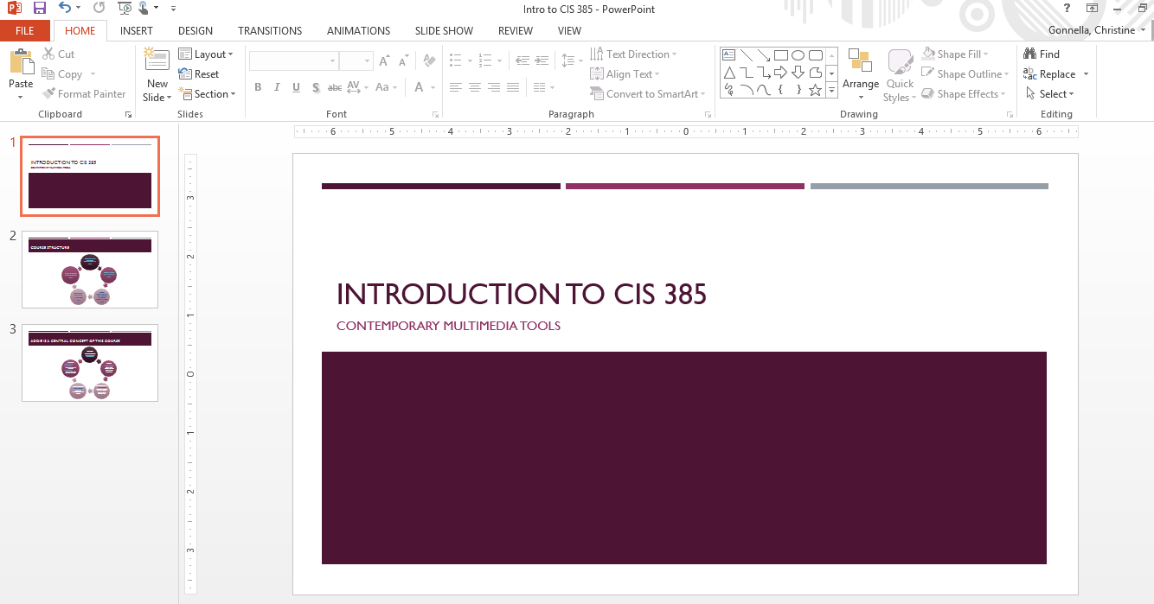
Login to Moodle and navigate to the class in which you would like to record.

Click on the Tegrity Campus link to bring up the Record a Class page.

The link should appear on the right or left side of your Moodle course.

If this screen comes up, choose the link Click here to open your Tegrity sessions list.
Click the Start a Recording button.
The first time you click the Start a Recording button you will need to download and install the Tegrity Recorder. You will only need to this once.  Click Save File | 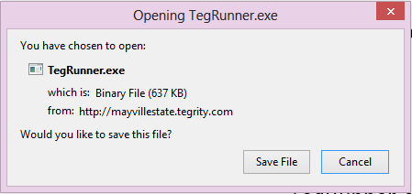
Go to your Downloads folder and locate the TegRunner file.

Double click and install.

Back in Moodle, click the Start a Recording button. | 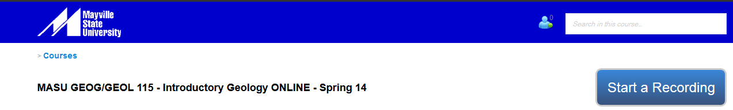
The Tegrity Recorder pops up.  You can edit the title as you like; follow your instructor’s naming requirements. We recommend that you leave the date and time in the title.  We also recommend that you upload a photo of yourself. To do so, click Select Picture, Browse the computer and upload your photo.  To record a video of yourself, check the Instructor Video box. This should start your internal webcam. | 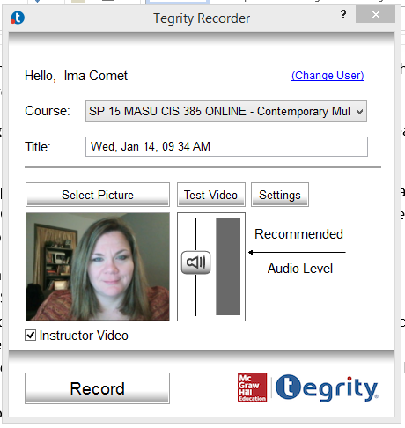
If you have an external camera you may have to use Settings to tell it to interact with Tegrity.

Under the Video Settings header, click on the drop down arrow to find and choose your camera.
To select your audio device (a headset works best for audio), click the Default audio source drop down and choose the mic you wish to use. If you are not sure, experiment with the devices on the list. | 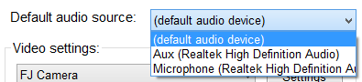
Perform a Test Video to ensure your video and audio are working properly.
If you are still having audio problems, go to Control Panel > Sound > Manage Audio Devices and select the device you prefer.  If this does not work, you will need to call the Help Desk. | 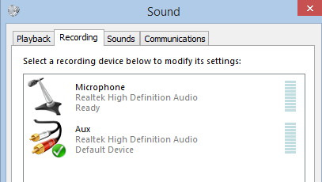
Once you have your devices working, navigate to the window in which your materials appear.  If you are using PPT, this is when you should enter Slide View mode. The Tegrity Recorder window will stay on top until you click Record.  When you’re ready to begin, click the Record button. | 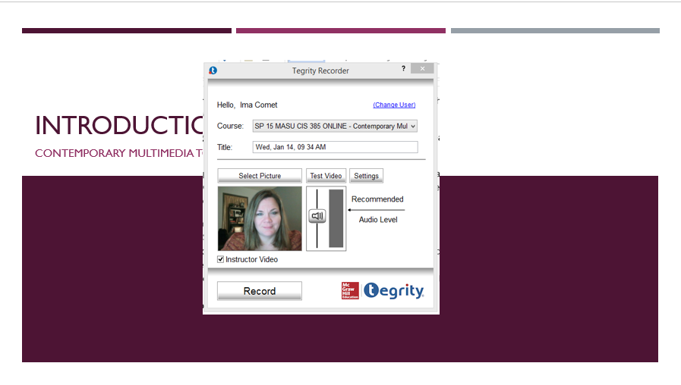
If you are using more than one monitor, Tegrity will ask which monitor you want recorded. Use the arrows to navigate to the monitor you want, or stay on the current monitor, then click Record this Monitor. | 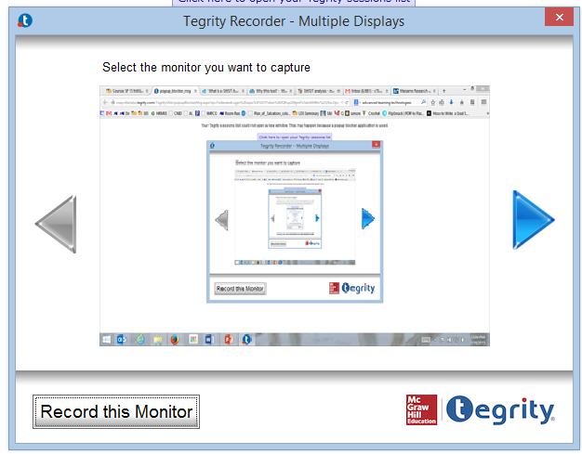
A message about the Tegrity Recorder will pop up every time you try to record unless you click the Don’t show this message again box. | 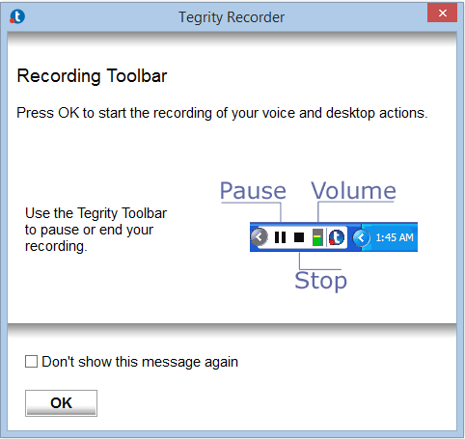
While you are recording, there will be no indication other than the menu bar on the bottom right of the screen. | 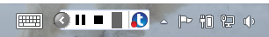
When finished, click the Stop icon in the Tegrity toolbar in your system tray.
Choose one of the options on the Do you want to end the recording? window.  Upload (in the background) confirms that the recording will stop and will be uploaded.  Preview stops the recording and allows you to view it without uploading.  Delete will stop the recording completely delete the video. | 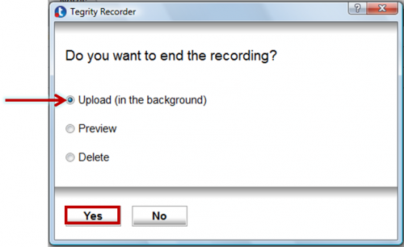
You will be notified that the recording is complete and will be uploaded later. | 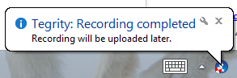
If you have chosen to upload the video, it will show up in the Student Recordings tab. | 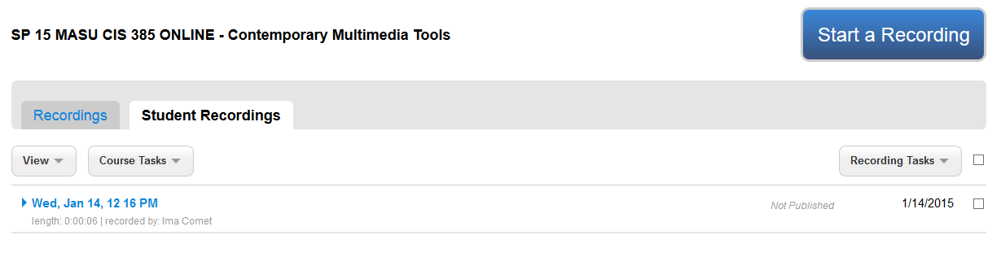

If you have any problems with this process, contact Sheena Moe at 701.788.4645.

