Add a Label
Labels are used to help visually organize a course or add text to the main course page.

Navigate to your course in Moodle
Turn editing on. | 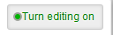
Click Add an activity or resource | 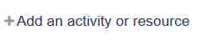
Scroll down into the Resources section to locate Label.  Double click Label | 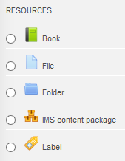
Enter the text of your label. | 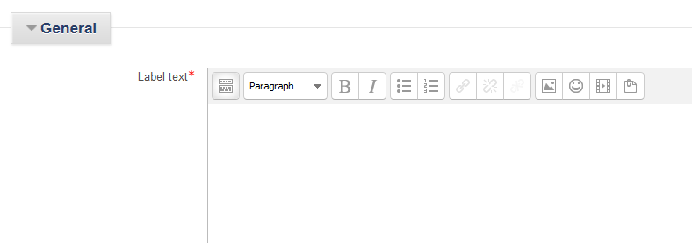
For more editing options, click the Toolbar Toggle button. | 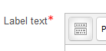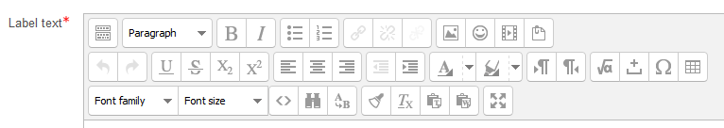
Save. | 