How to move recordings to your Private Course
*You must be an instructor in the course in which the recording exists to perform this function.
1. Click the check box to the right of the recording(s) you want to move (A), click on Recording Tasks (B), and click Move (C)
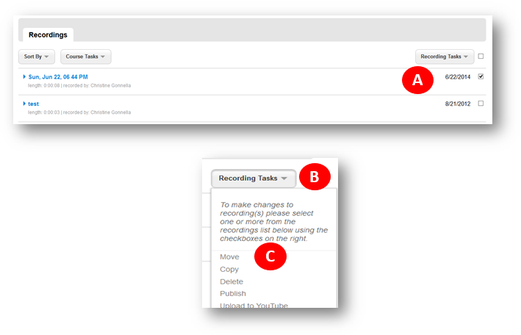
2. Select the course labeled <Your Name> Private Course and click Move Recording(s).
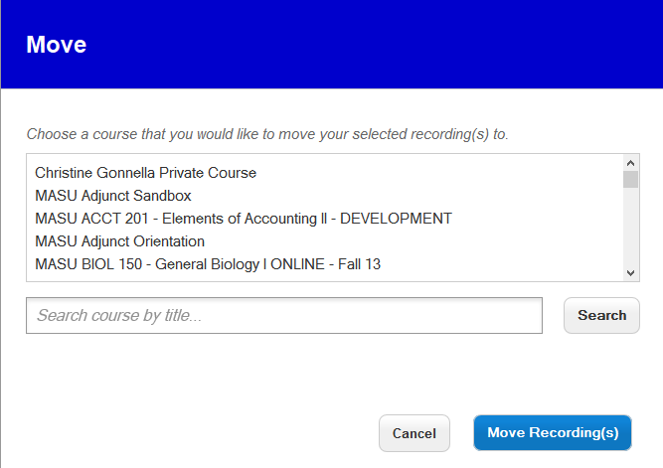
3. You will get the message that your recording(s) have been queued for move. Click OK.
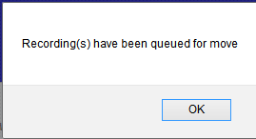
Your recording(s) will be moved to the Private Course.
To ensure that your recording was moved, go to the upper left corner of the screen to find the Courses link. This link takes you to all your recordings.
Click into your Private Course.
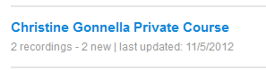
Locate your recording.
To get back to the course you were working in, click the Courses link in upper left corner.

