How to move recordings from one class to another

*You must be an instructor in both courses to perform this function.

1. Click the check box to the right of the recording(s) you want to move (**A**), click on Recording Tasks (**B**), and click Move (**C)**

[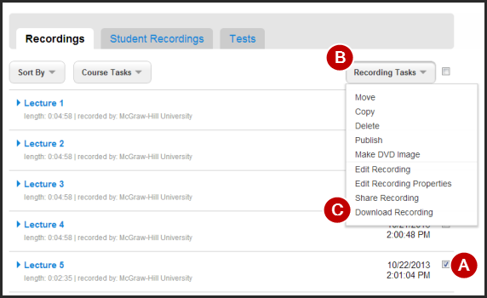](https://help.tegrity.com/wordpress/wp-content/uploads/2010/07/downloadweb.png)

2. Select the course to which you would like to copy the recording(s) and click “Move Recording(s)”.

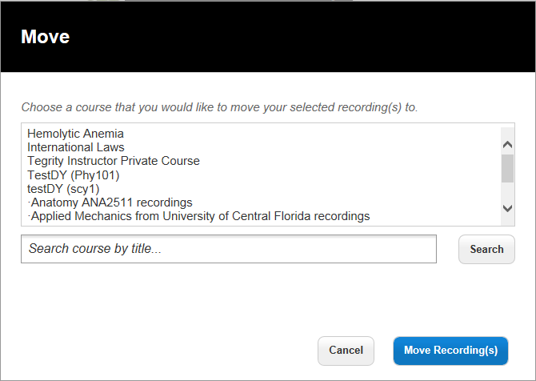

Your recording(s) will be moved to the course you have selected.