Enter the Tegrity block in your course
- Turn editing on.
- Find the “ADD A BLOCK” section.
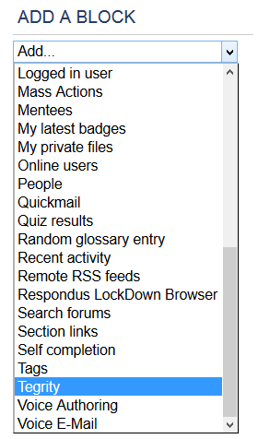

- Scroll down and locate the Tegrity block.
